# Introduction

This document describes my learning of OpenGL 4.0. It’s mostly intended to be a journal for myself as I learn – and I’d like to track my history these days.

When I learned OpenGL, I took two courses that used version 2.1. This was back in about 2008 so I’ve been using those tools to do many high level projects (character animation, physics animations, computational geometry, CUDA, and hybrid ray tracing algorithms). Since I was using 2.1 and I stopped paying attention to OpenGL updates, I didn’t know how much it was changing. Now I realized I know nothing about OpenGL anymore, so I decided it’s time to learn again.

I bought the book OpenGL 4.0 Shading Language Cookbook – now I’m plugging through each of the examples to re-learn OpenGL. I received the book February 3, 2012 (after a massive binge drinking weekend with my old college friends) and now I’ll start learning.

# Rotating Triangle

Vert and Frag shaders were the only shaders I learned in college. They used to be an advanced technique, and now it’s the first thing you need to draw a triangle. There is no longer a matrix stack, so you do everything yourself. So far it looks like it’s a lot more flexible than it used to be!

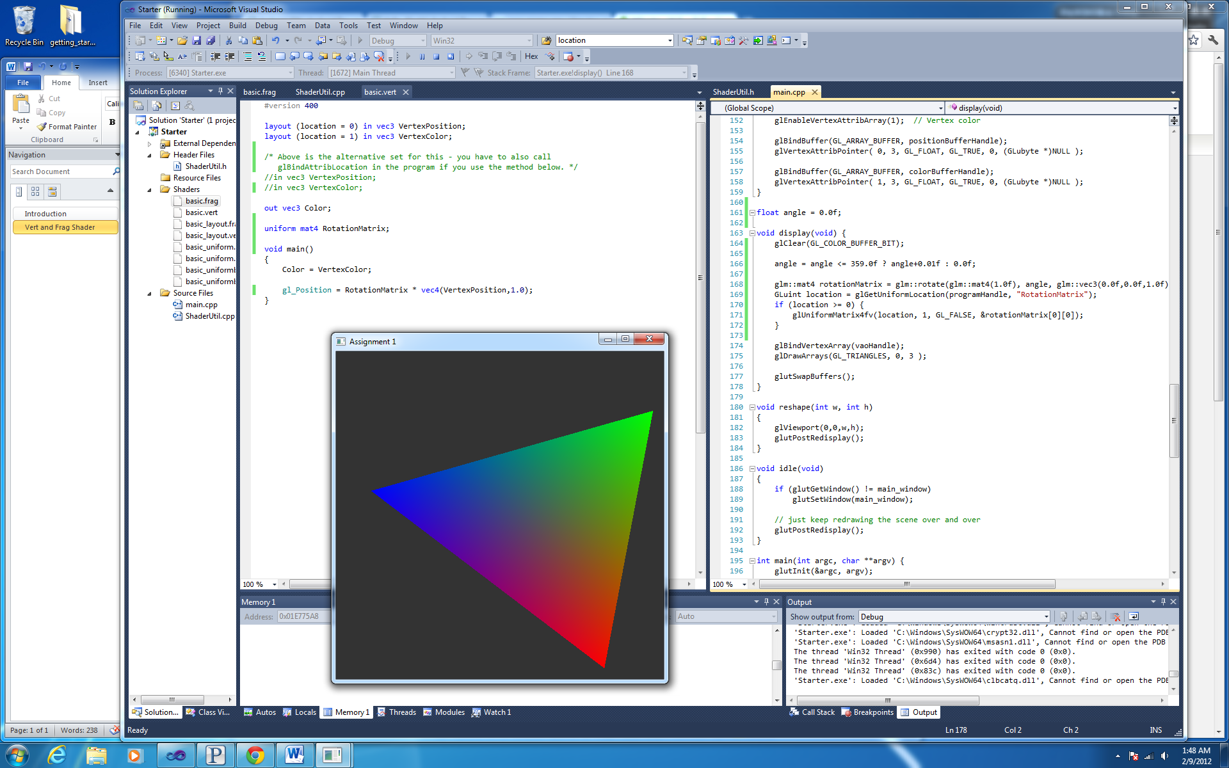

2.2.12 - Simple rotating triangle

# Simple Shading

This session I implemented Utah’s shading model, with Utah’s red. I stole some code to load the Utah Teapot. I haven’t implemented or stolen a track-ball to look around the 3D-object, but I have the perspective view with basic lighting.

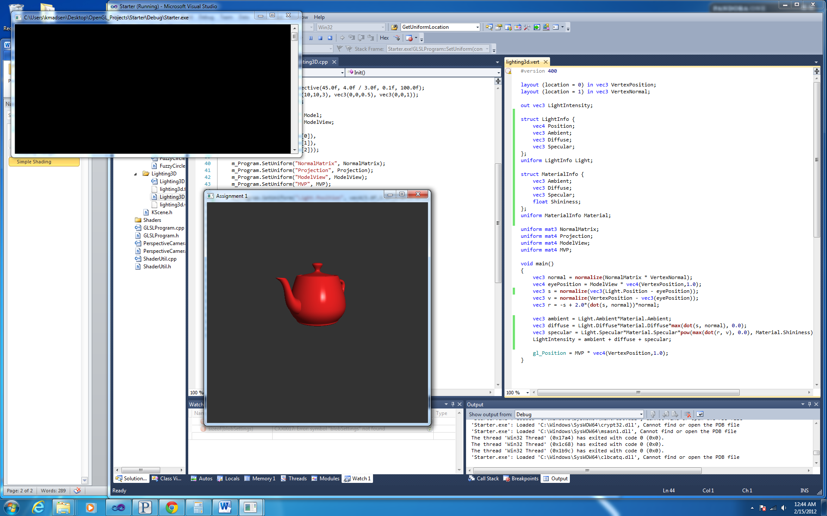

2.15.12 – 3D view with Phong Shading

# Toon Shading

It was pretty simple to add toon shading. I also refactored and added resize capabilities. I’ve never done toon shading, but I wasn’t missing much (it is super simple). But this session I added lighting to the fragment shader rather than it all being per-vertex.

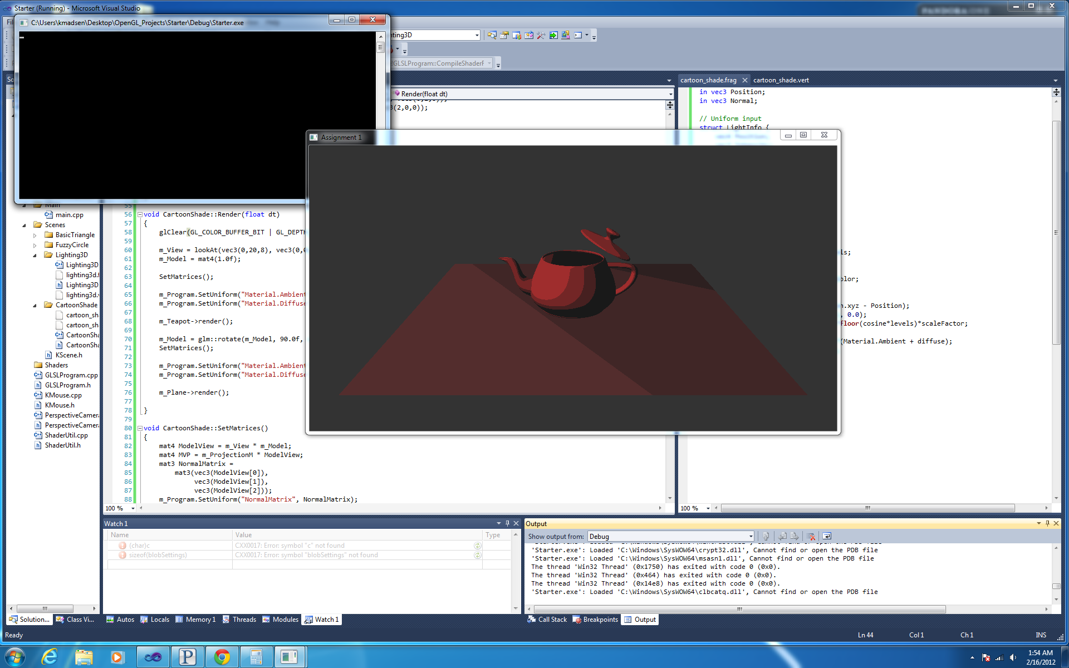

2.16.12 – Toon Shading

# Texture Mapping

It took me a little longer to figure out how I wanted to deal with images. I spent some time trying to get Qt up and running, but I pretty much failed (must have missed something). Instead I just used FreeImage, which is pretty simple and nice. I think I’ll use it more often since it has a lot of useful routines. Anyways, now my teapot is textured like a brick.

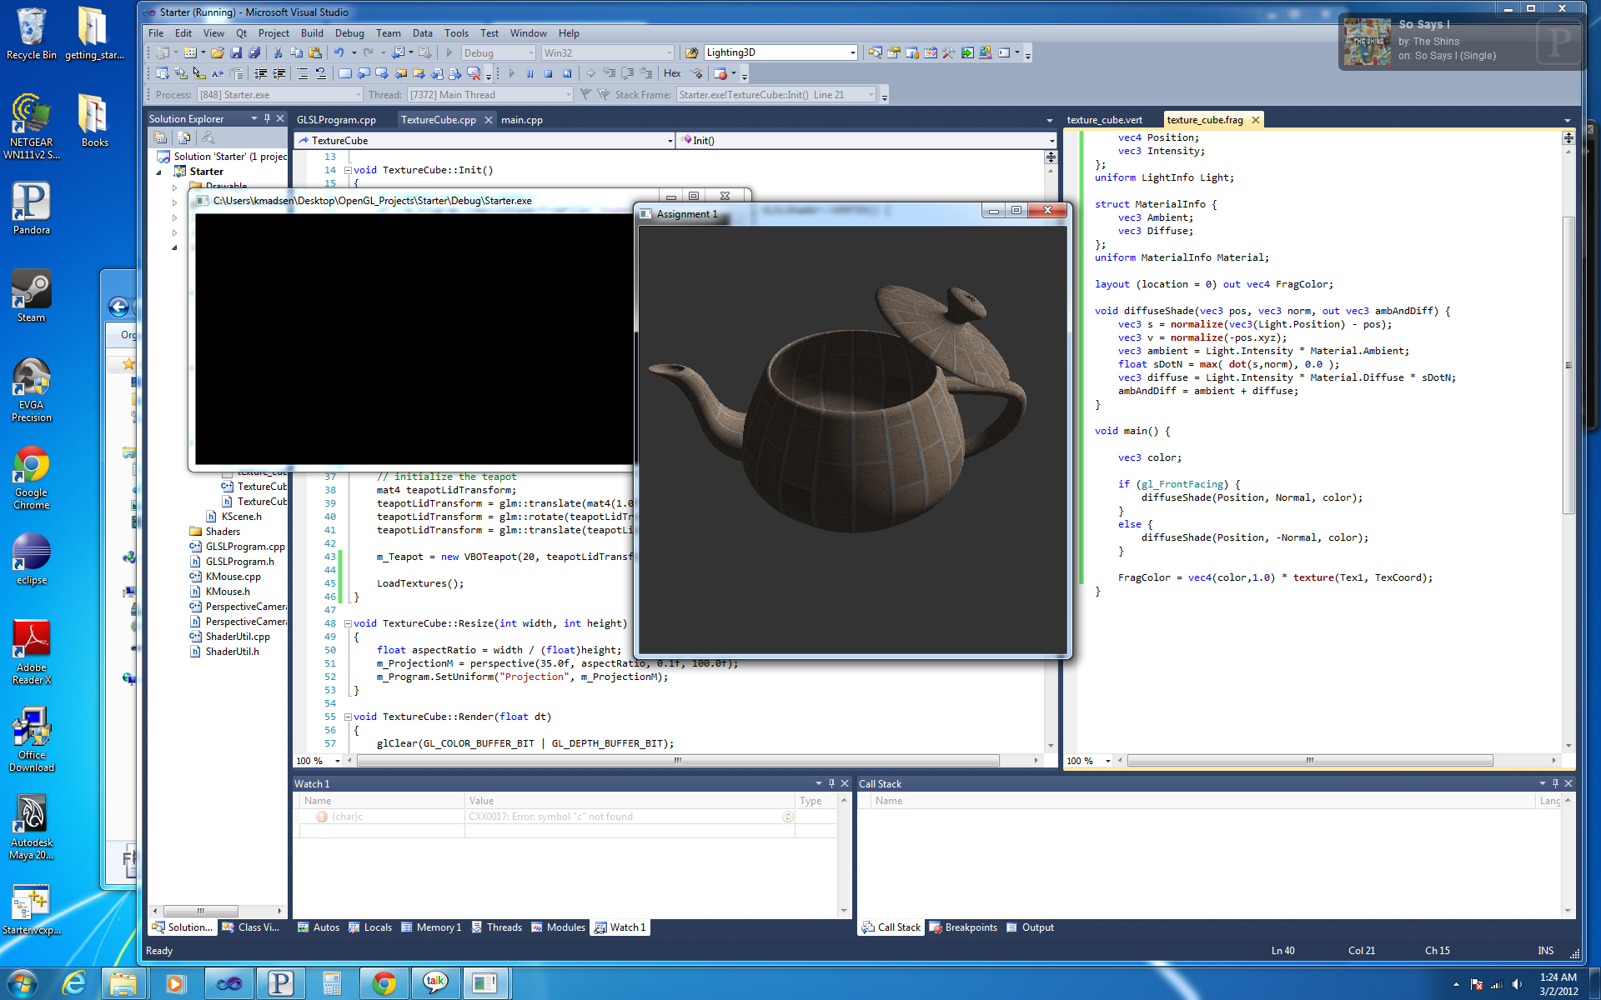

3.2.12 – Texture Mapping

# Bump Mapping

I stole a pretty good model from the resources included from the book. The bump mapping took me awhile to understand where to do the math. The model is nice because it includes a tangent vector and a normal vector for every vertex. This makes the basis for each vertex a simple cross product. Before when I did normal mapping, the mesh didn’t have this tangent vector and now I know I pretty much did it wrong. This time I did it right, and I’m now pretty used to writing GLSL vertex and fragment shaders. It has also been awhile since I used multiple textures on a surface, with the new hands-on nature of OpenGL, this was straight forward (or maybe I just have a better understanding these days).

I also put in some user interaction methods. Now I can use the left mouse button to spin the model, and the right mouse button to move the camera (as if you were turning your head). Then some simple keyboard inputs to move the camera around (the WASD keys).

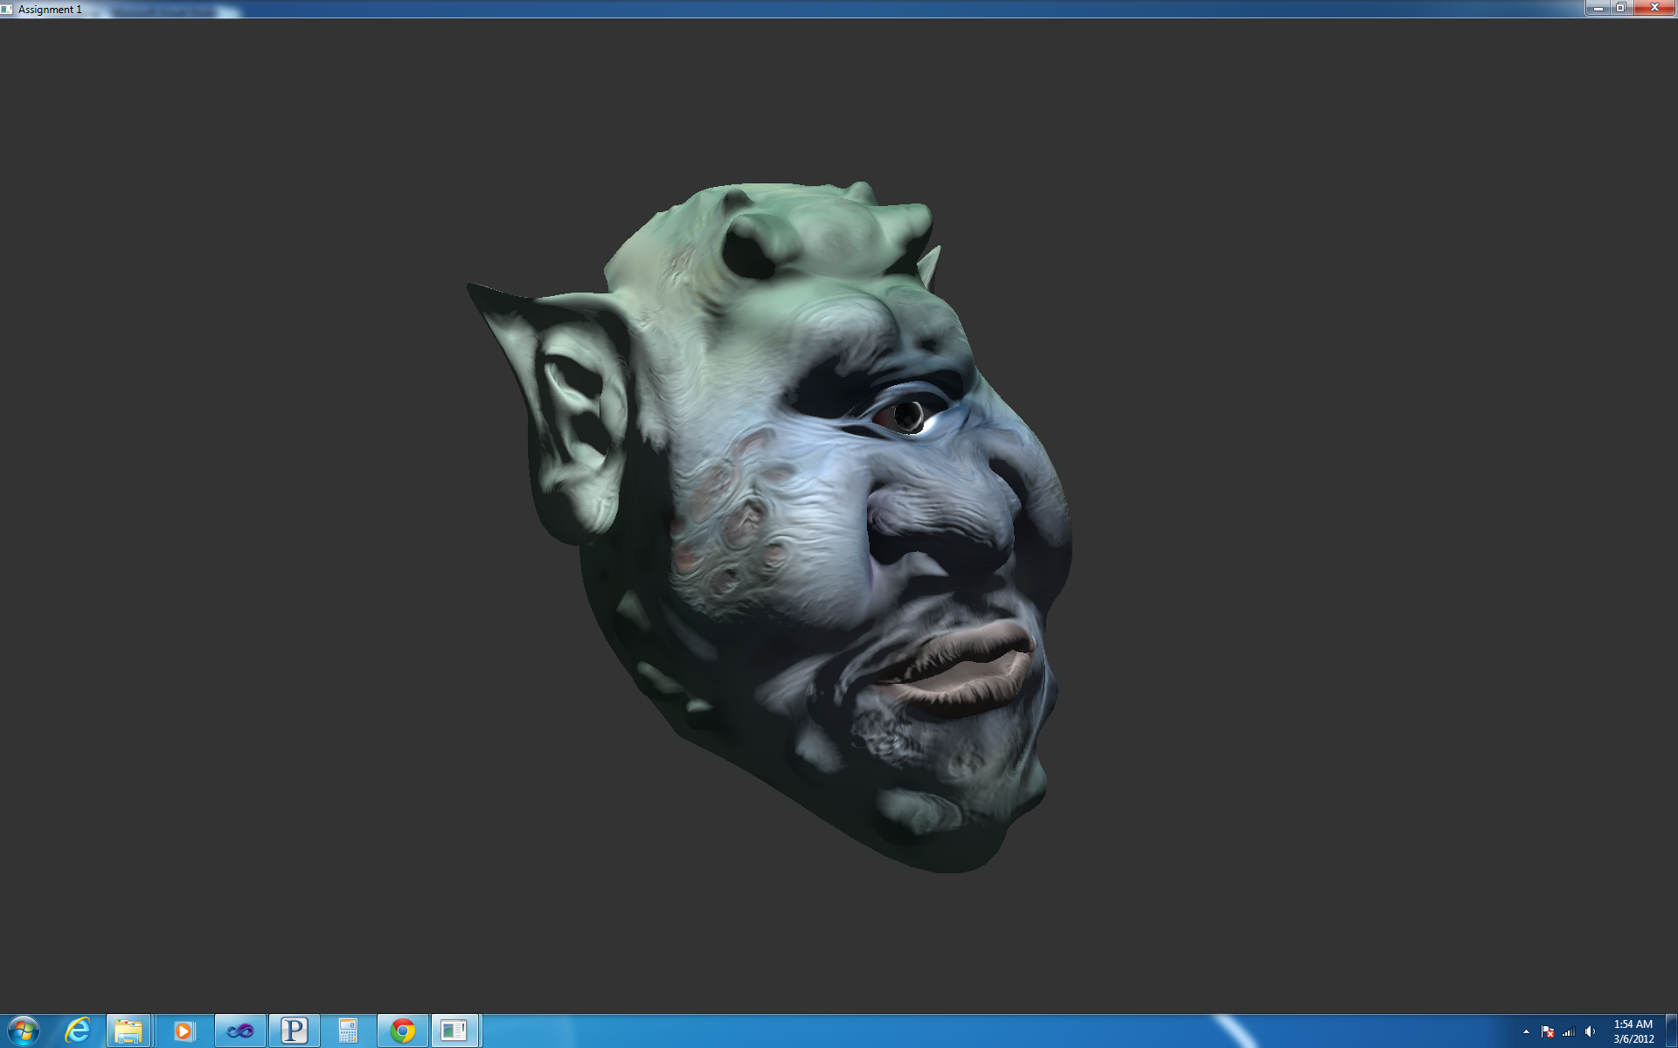

3.5.12 – Bump Mapping

# Environment Mapping

This is starting to get fun, and I pretty much stopped following the book. This scene has a couple cool things in it. First, I added a skybox that follows the camera around. I used the trick where you disable the depth test and have the box follow the camera around. Next, I created a cube map out of the textures and made a reflective teapot. I’ll add refraction here in a second since it’ll be just a couple more lines. Before today, I’ve only read about environment mapping, but I was surprised how easy it was. For fun, I also added in RGB wavelengths to give chromatic aberration.

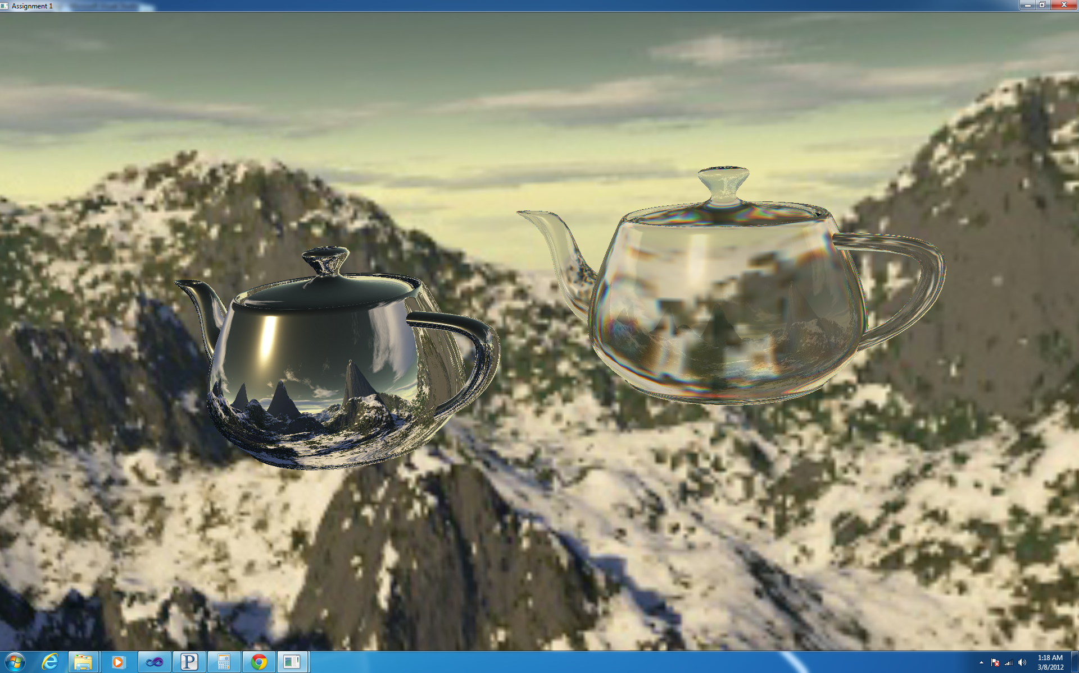

3.7.12 – Environment Mapping

# Projection Texture

This was a little difficult to get correct. I had to re-think my math a couple times before I got all the bugs out. This was hard to debug because nothing was showing up on the screen. This method is pretty much a projector though, I didn’t add anything other than just the texture and a simple diffuse lighting, but here’s the image.

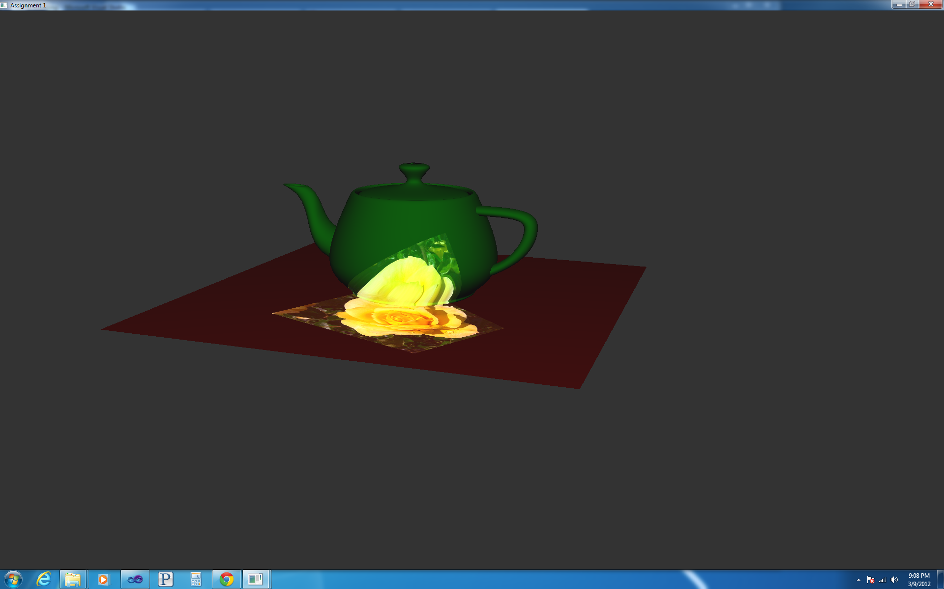

3.9.12 – Projection Texture

# Point Sprites

So far at Intel, it seems the geometry shader is hardly used. For this project this seemed like a useful thing to do. The vertex and fragment shaders are completely simple, the vertex shader passes along points, and then the fragment shader samples a billboard texture. The geometry shader converts the points to rectangles, and it’s as simple as that. The way I did billboard textures in the old OpenGL was similar, but this seems simpler. All you have to do is update points (maybe do that on a compute shader or cuda). Then you have a very fast particle system.

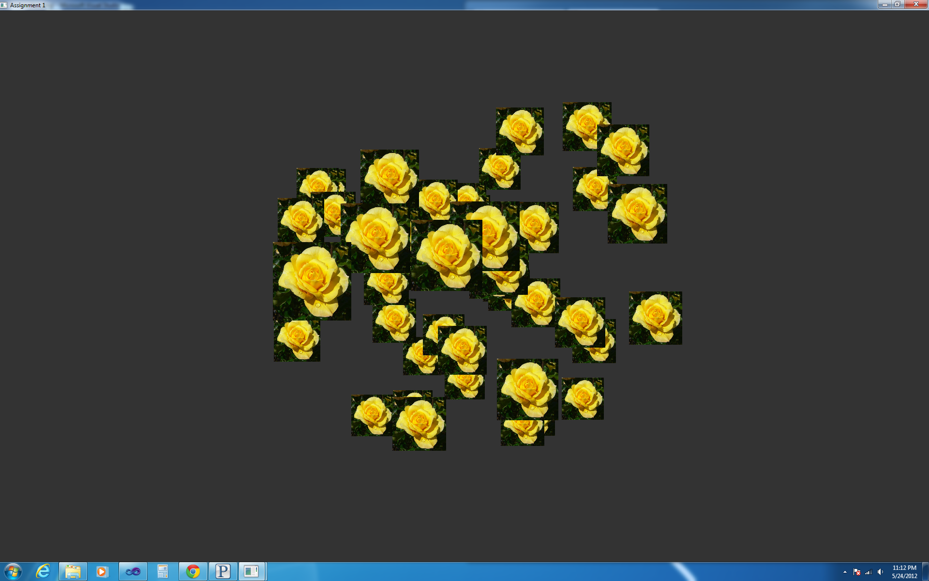

5.24.12 – Point Sprites

# Wire Frame

This little project dug deeper into the geometry shader. I thought this was cool because you get anti-aliasing with the wire frame without doing much work. This was also interesting because it doesn’t actually alter the geometry; instead it is just making use of the pipeline. The math was a little bit tricky, and there were a few new concepts that I had to study a little to grasp. But here is a wire frame ogre!

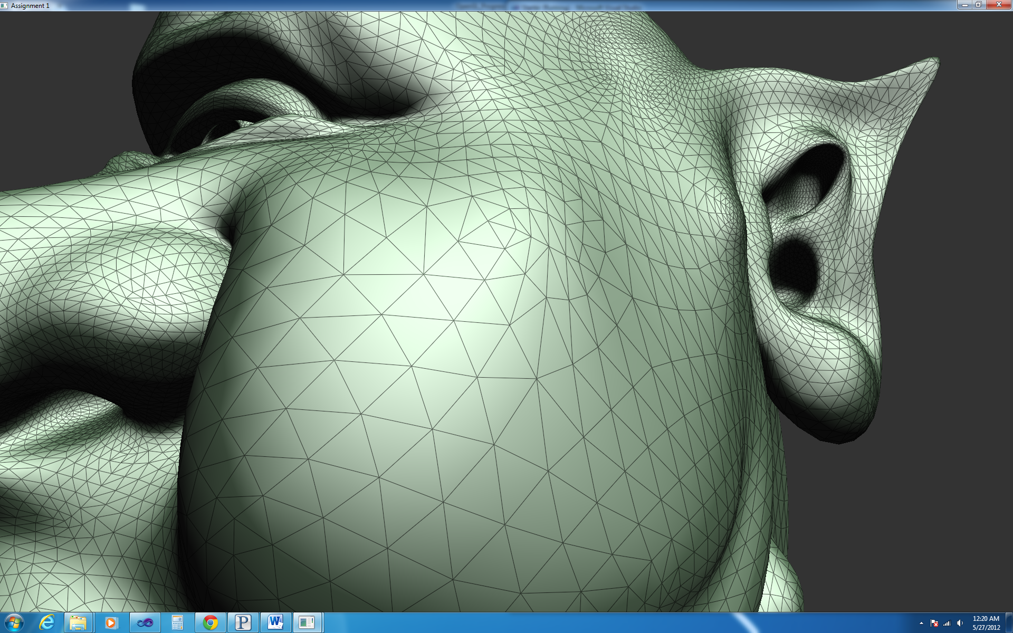

5.25.12 – Wire Frame

# Tessellation

Finally, I tessellated. I have to admit that I cheated a bit. I just used the same code to bring over the wire frame using the geometry shader. Then the tessellation level is created based on the distance from the camera. But I essentially stole all the tessellation code for interpolation. I was going to do just a 2D curve, but I wanted to get the full effect. Later I’ll make some projects or effects of my own. I finally understand how the pipeline works though for tessellation.

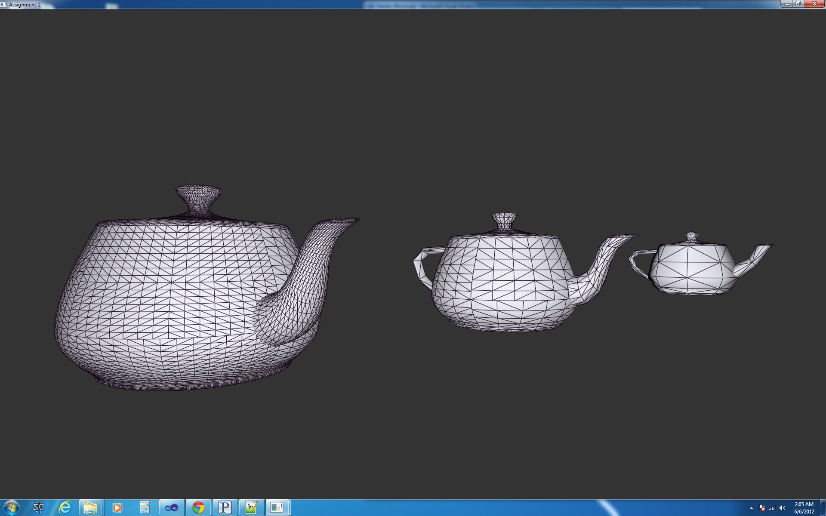

6.6.12 – Tessellation

# Shadow Map

It took me awhile to figure out how to get this correct; I didn’t fully understand frame buffer objects, the bindings, why I need to cull the front faces, and the math. I had to spend time in each of these areas to grasp better what was going on before I could get something correct on the screen. I can see I could spend plenty more time on this to get shadows better and more correct, but I basically copied the scene from the book and got it to work on my own. It was pretty rewarding to get some shadows though!

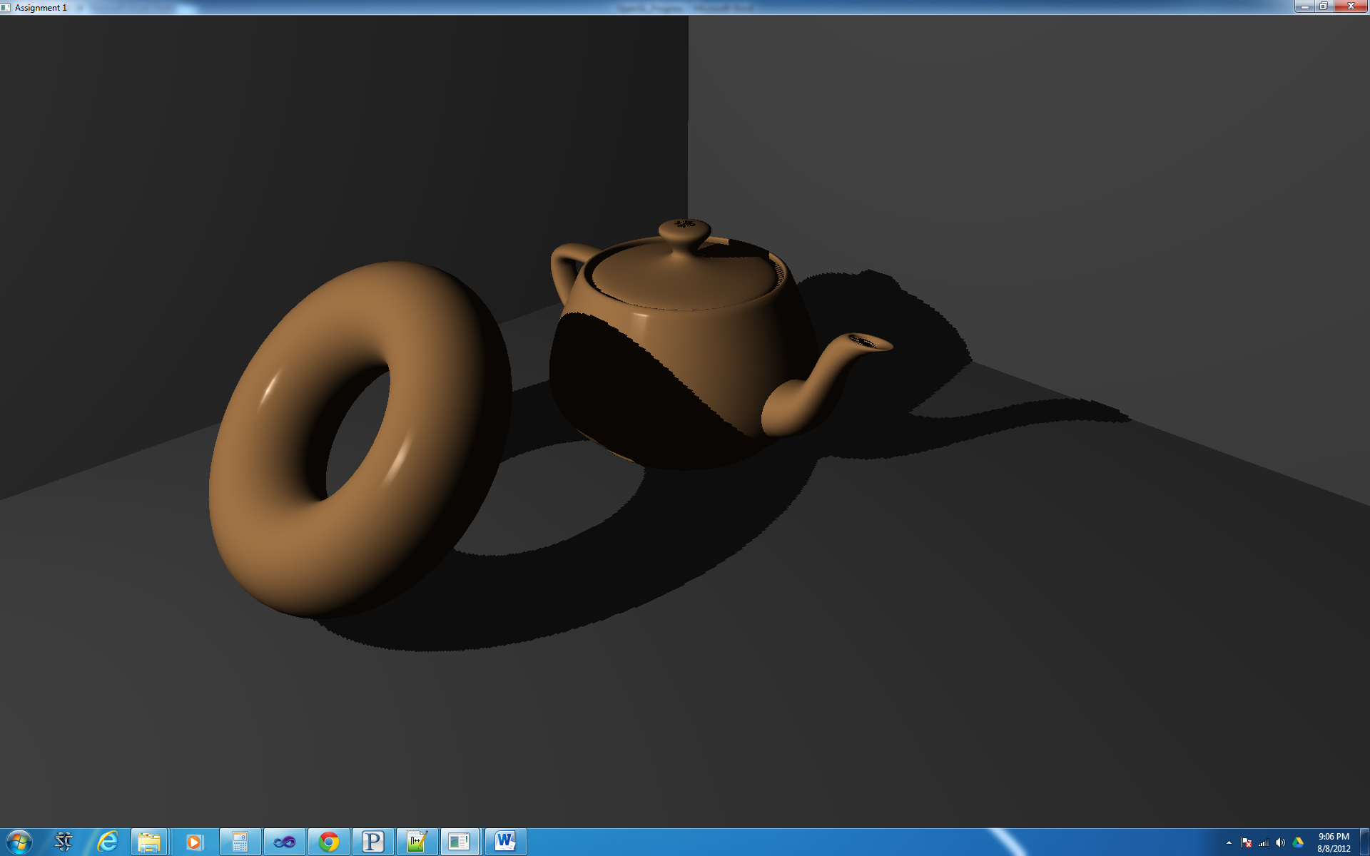

8.8.12 – Shadow Map

# Vertex Animation

I have done a similar project before in school; our assignment was to make a wiggling snake (which was slightly more complicated). This was pretty simple since it was just a plane. I made everything parameterized so you can change what the wave looks like, but it’s still a boring wave. To add a little bit of fun, I made the color different based on the position (still pretty lame).

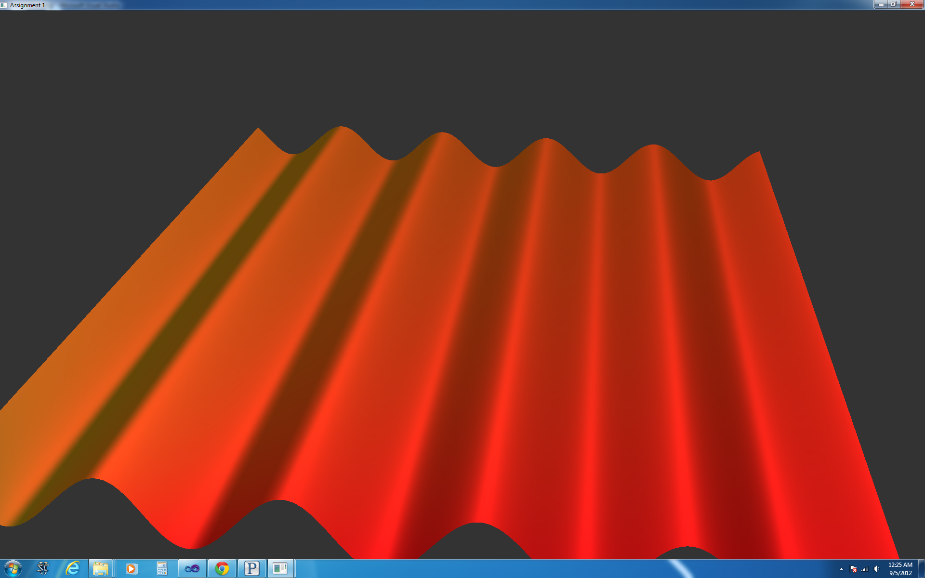

9.5.12 – Vertex Animation